CSE321 Project 2

# Ask

## Purpose

Design a countdown alarm system that can be controlled by a user to set the countdown time, start and stop the timer, and be alerted of the remaining time by the LCD display.

## Inputs

* 4x4 Matrix Keypad:
  + Buttons for Numbers 0-9, A, B, and D

## Outputs

* LCD output display
* LEDs (4)

## Relationships

* Any time any keypad input is detected, a single LED will light up until the key is released.
* Numbers 0-9 are used to set the timer duration when the timer is set to input mode. During input mode, the LCD outputs a prompt to set the timer duration and displays the duration that has so far been entered. The maximum duration that can be input is 9 minutes and 59 seconds.
* Button A switches the timer to countdown mode. During countdown mode, the remaining time goes down by one second per second from the input timer duration down to 0. The remaining time is displayed on the LCD in this mode as “Time Remaining: **m:ss**”.
* Button B
  + clears the remaining time if the timer is currently counting down
  + exits out of the alarm mode if the timer has counted down to zero
* When the countdown timer reaches zero, the timer switches to the alarm mode in which multiple LEDs will be on.

# Research/Imagine

A 4x4 matrix keypad can be used to receive a sufficiently large set of unique inputs to handle all input conditions defined for the system.

The Nucleo L4R5ZI can be used as the microcontroller to create the desired system outputs in response to the system inputs.

A JHD1804 LCD module can be used as the primary user interface output. LEDs can be added for greater emphasis and to confirm user inputs are registered.

All of these components will need to be connected on a breadboard to connect with each other appropriately.

# Plan

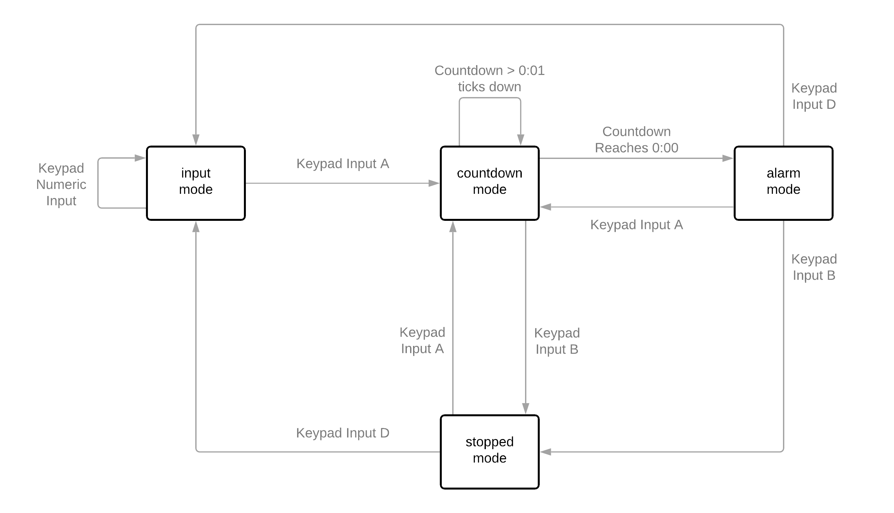

Internal variable notes:

* The countdown start value will be preserved between consecutive uses in the alarm in which the system does not lose power and does not switch to the input mode.
* The countdown start value can be set by switching to the input mode (Keypad Input D) from any state.
* The active countdown value will be overwritten to equal the countdown start value every time the system switches to countdown mode (Keyboard Input A).

Outputs in each mode:

* Input mode:
  + LCD: “Input timer duration: <m:ss>”
  + LEDs: off
* Countdown mode:
  + LCD: “Time Remaining: <m:ss>”
  + LEDs: off
* Alarm mode:
  + LCD: “Times Up”
  + LEDs: on
* Stopped mode:
  + LCD: “Timer stopped”
  + LEDs: off